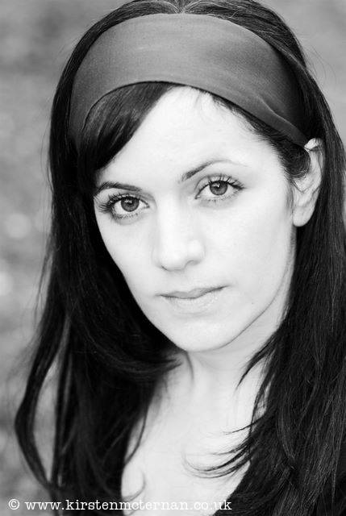
Lisa Jouzdani
Bigfoot CV

DBS Number: 001475930727
Issued: 12th February 2015
Update Service: NO
Bigfoot Arts Education guarantees that all appropriate checks in respect of safeguarding children have been carried out.

A bit about me…

Lisa graduated from The Royal Welsh College of Music and Drama in 2003-Since graduating she has worked extensively in TV/Film and Theatre, Lisa is also a voice over artist. She has performed for young people nationally and internationally, performing in theatres and schools, and running workshops with children from ages 5-18 years. Lisa is also a freelance director and voice coach, and a directing tutor for LAMDA exams.

My art specialisms…

- Vocal Coach
- Physical Theatre
- Shakespeare Workshops
- Stage Combat

Me as a professional artist…

- Played Soraya in the European premiere of The Kite Runner
- Played Hermia in a National tour of A Midsummer Nights Dream
- Voice over artist for BBC Bitesize Science
- Performed as Juliet, in Romeo and Juliet on the QM2
- Toured with Theatr Clwyd to Warsaw, Poland
- Performed in the film Skellig, starring Tim Roth

Me as an experienced facilitator

- Director, Pimlico Academy.
- Performer and Facilitator in schools around Wales with Thear lolo –TYP
- Performing and Touring Mid Wales.
- Performer and Facilitator, New Vic Theatre Stoke – TYP.

My Education & Training…

Bigfoot Arts Education | 2015 | Secondary PSHE
Royal Welsh College of Music and Drama | 2000-2003 | 2”1 BA hons Acting
Gorseinon College | 1997-1999 | A –a level drama/C- a level English Lang /lit E –a level Media Studies
Gorseinon College | 1998 | A –g.c.s.e. Media Studies
Pentrehafod Comprehensive | 1992-1997 | 8 g.c.s.e.s

