Bigfoot Summer School – Transition
Cranbrook Educational Campus, 24th-28th August 2015

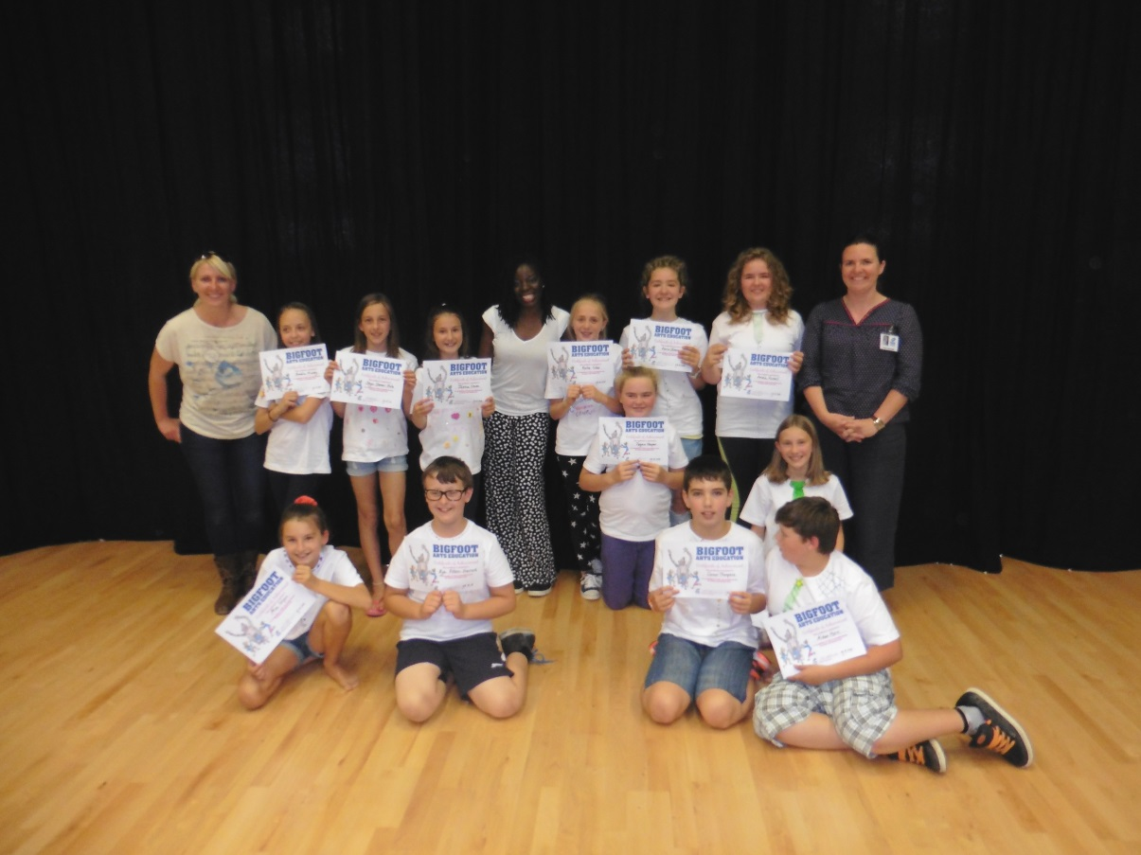

Aims
The aim of this week was to introduce future year sevens to Cranbrook Educational Campus, and to support the young people in making this transition. The participants were year six leavers from a variety of schools in and around Exeter, so one of our main aims for this project was to introduce them to one another and create a sense of familiarity and friendship between the children. Additionally, we wanted to explore their move to secondary school – any concerns that they might have, anything they were looking forward to, any problems that could arise – and ensure that by the end of the week, children had developed a sense of familiarity with their new school, and were feeling more confident about joining in September.

Background to the course

While all of the Bigfoot practitioners had previous experience in delivering summer schools, Cranbrook Educational Campus provided an interesting additional challenge in that it is a brand new school – the children entering year seven will be the first pupils ever to study here. Most were moving from large primary schools, and while the building is enormous, they will be one of only 30 - 60 pupils studying here for the first year. This was a new experience for both the pupils and the directorial team, with the potential for a variety of additional challenges. The course was booked to ensure that the pupils felt as positive as possible about such a drastic change, and to allow them to adjust to this different working lifestyle before school began.

Kat and Lolade have both been worked for Bigfoot London for several years, and have a wide range of experience in working in the arts, particularly with young people. Between them they have specialist skills in drama, music, movement, and writing, and have been using these skills to allow young people access to the arts for many years. Both understand that the arts are fundamental to a child’s education, and allow them to develop skills such as confidence, teamwork, reasoning and concentration. In addition to allowing the children of Cranbrook Educational Campus an opportunity to explore the arts, this week was a chance for the participants to explore and develop these skills, in anticipation of starting the next phase of their education. Bigfoot South West has long been a promoter of this philosophy, and it is their belief that the arts should be accessible to everyone that makes their summer schools unique.

Participation
As children arrived on the first day, we invited them to partake in a confidential survey by placing marks on two different bulls eye targets. The first being “How confident do you feel about starting at Secondary School?” (centre being very confident, outside being not confident at all), and the second “How well do you know everyone in the room?” (centre being very well, outside being not well at all) We discovered that while most participants seemed to feel OK about secondary school (almost all selected “not too bad” or “pretty good” about starting in September) most did not feel that they knew all of their fellow participants very well. Most came into Summer School recognising a few people from primary school, and were more inclined to stay with those they knew as they first arrived. Overall the group were very quiet and seemed nervous as they first arrived, appearing very unsure of themselves and what was going to happen this week.

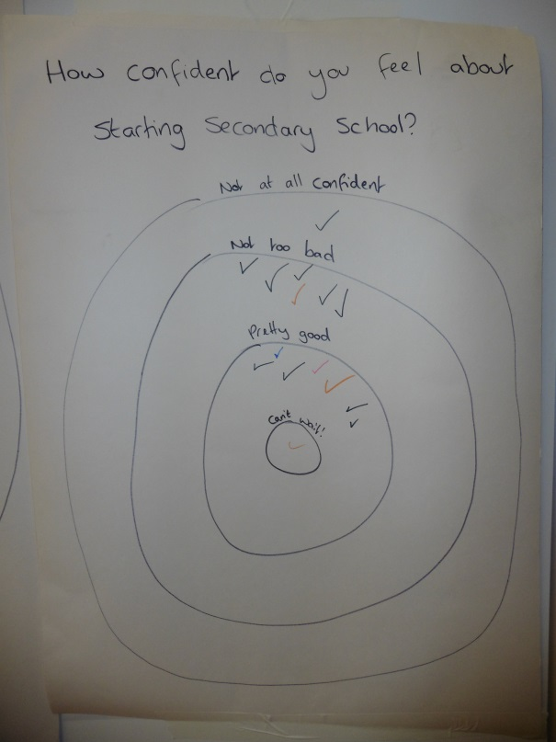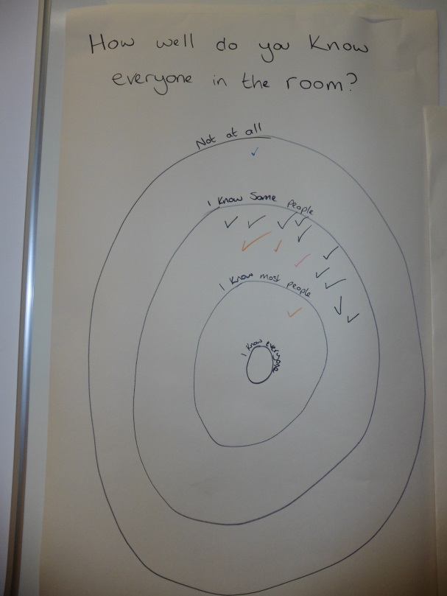
How confident do you feel about How well do you know everyone
starting secondary school? in the room?

The session began with some simple games such as Zip, Zap, Boing! and Zombie, all chosen as something everyone can get involved in without too much pressure at this early stage. All of the children engaged well with these games, and while they still seemed quiet and apprehensive, they began to relax as they started to enjoy themselves. We then took some time to introduce the creative team and discuss expectations for the week. Instead of the directorial team establishing the summer school rules, we allowed the participants to make their own suggestions for the rules we should follow for everyone to have a great week. These were then compiled into a contract for the week – a professional agreement which we all signed, agreeing to the guidelines that we had established for the week. This allowed the participants to take responsibility for their own behaviour, instilling the idea of the increased independence and maturity that will be expected at secondary school.

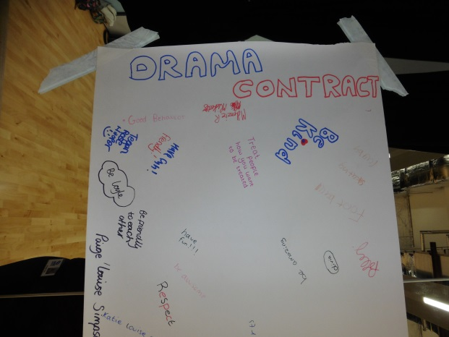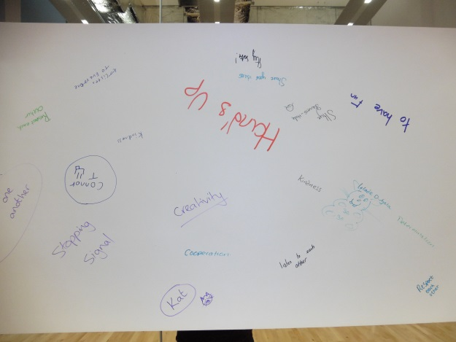

After a short break and some more group games, we began discussing how someone might feel about starting secondary school (we made sure not to make it personal at this point, and instead asked for general ideas rather than personal concerns) I was extremely impressed with how mature the students were when discussing these feelings and emotions – they were able to discuss a range of positive and negative emotions with real sensitivity, and excellent vocabulary and explanations. Interestingly, as our participants will be the first children to ever study here, a lot of the usual concerns with starting a new school (such as bullying from older children or getting lost) were not commented on as much. However, there were several other concerns in their place, such as standing out for the wrong reasons, not making friends easily, and teachers picking on you more as groups will be smaller. As an extension of this discussion, children were split into groups and given the task of drawing around one member and writing down their observations on secondary school: thoughts in the head, feelings in the body, and other ideas around the outside. This gave us an idea of their main concerns about moving to secondary school, as well as some of the things they were looking forward to.

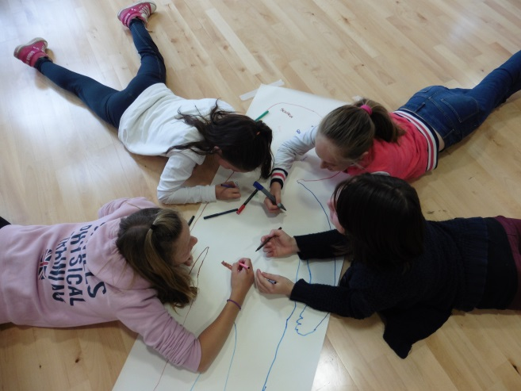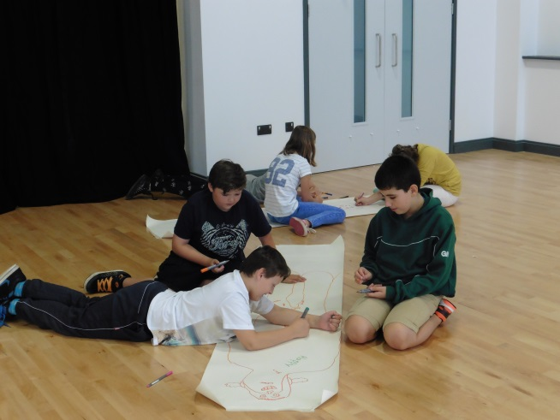

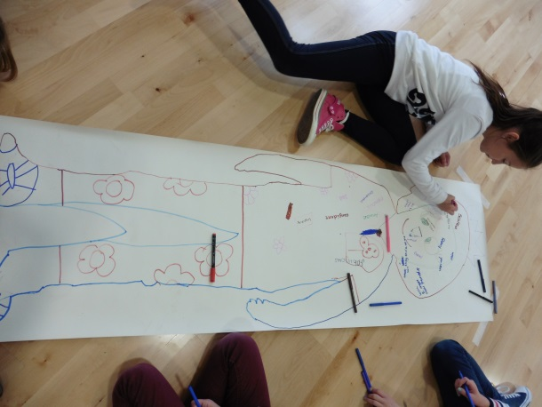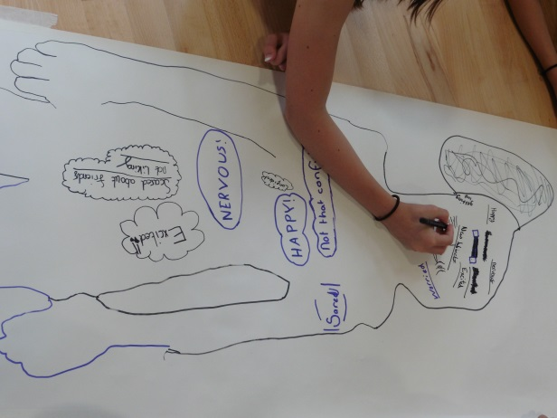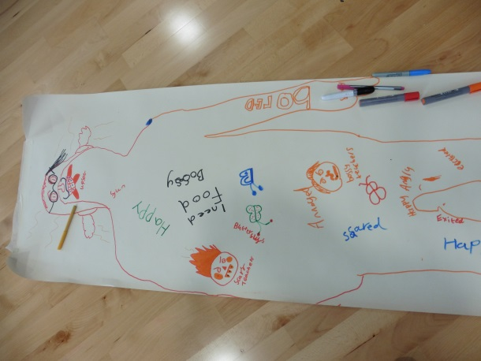

Our afternoon involved a gentle introduction to drama, in the form of tableaux. After briefly explaining the rules and expectations, we began trying some simple, individual freeze frames of different emotions. Once the students understood the concept, we began theming these tableaux to secondary school, taking inspiration from the body outlines that had been drawn earlier. I was genuinely impressed with the discipline that the students demonstrated during these tableaux – they were able to maintain stillness and silence, while at the same time telling a clear story with their bodies. They worked so well that we were able to progress from individual tableaux to group frozen pictures, with some fantastic results.

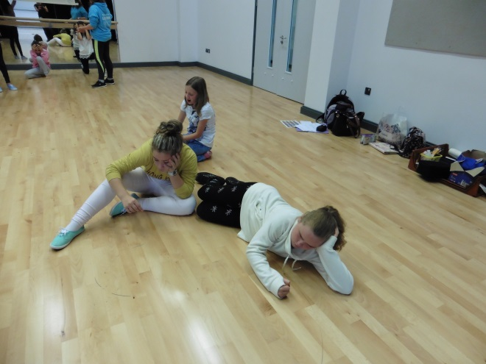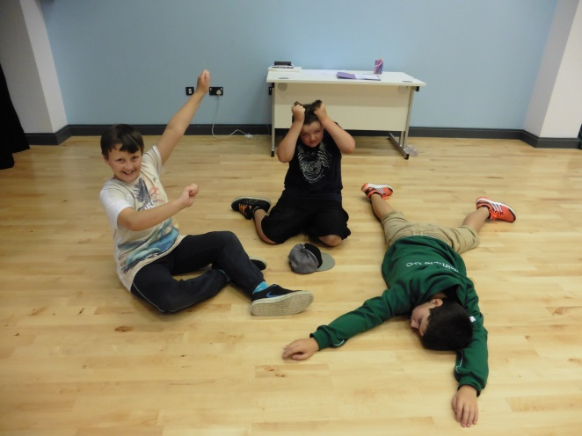

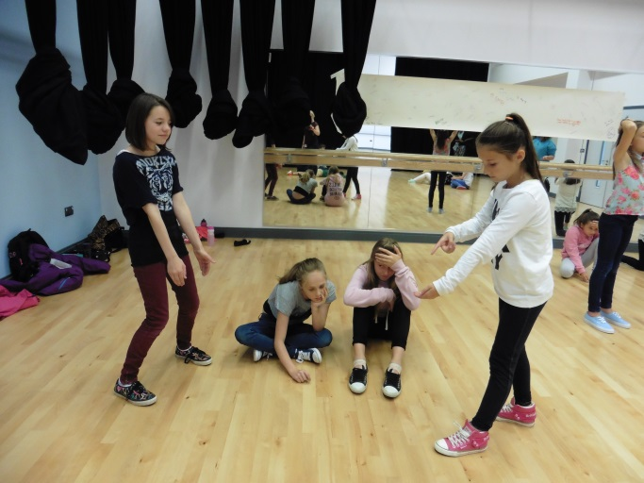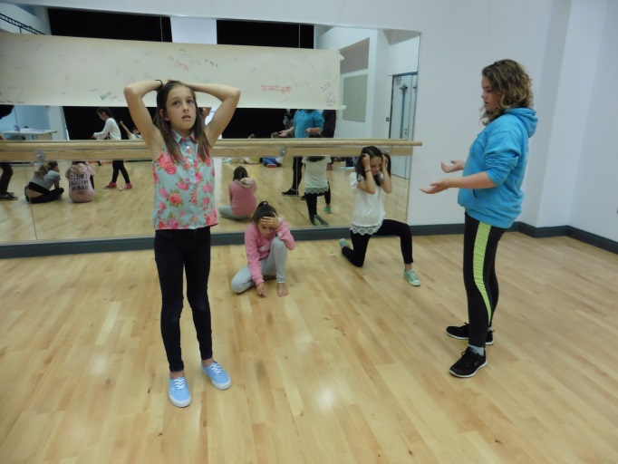

By the second day, children were already much more relaxed and confident around each other, and were beginning to demonstrate an increasing level of focus and understanding during games. For our first two morning sessions, students were split into two groups, and rotated between two activities. The first was improvisation, where students were invited to develop their performance skills and experience role play for the first time. The second was raps and body beats, which allowed children to experiment with creating different sounds and beats with their voices and bodies. Each group also thought about the potential issues that might arise while moving to secondary school, and used these to inspire some lyrics. They thought about the problem, how it might make them feel, the solution and the outcome, and organised these ideas into four lines of rhyming rap. This allowed children to not only consider what problems could be faced during transition, but to come up with a solution and understand what can be done about it.

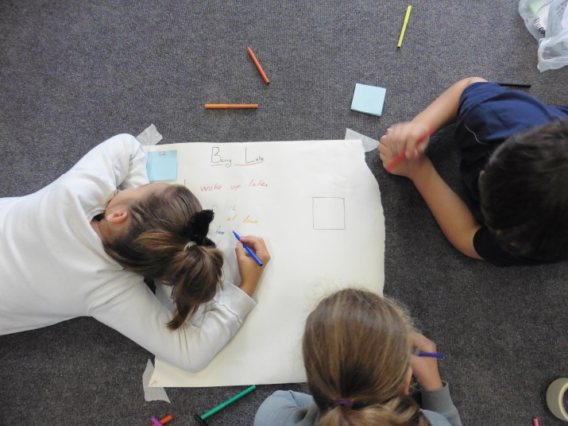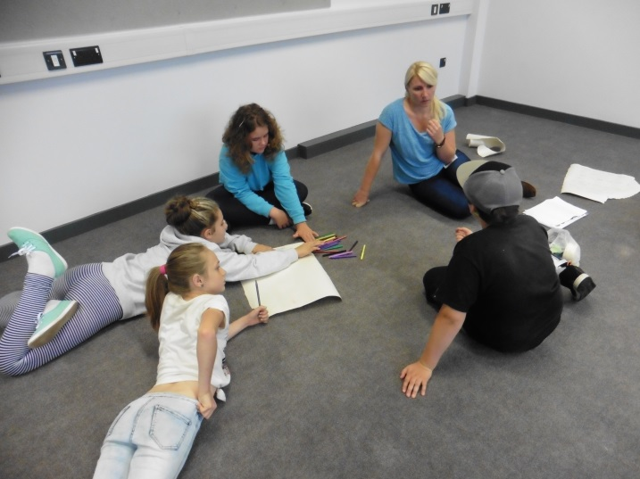

Continuing on the theme of problem-solving, we spent the afternoon working on Forum Theatre – an interactive art form that allows participants to solve problems in role, trying out solutions in a safe and secure environment. Each group devised a short scene depicting a problem that might occur when starting in a new school, but had to pause the action when they arrived at a “crisis point”. We then invited another student from outside the group to take the place of one of the actors and try to rectify the problem, in role.

This was a huge test for our group as this is an extremely difficult technique to master, but I was overwhelmed with how well each group rose to the challenge. It was a huge test for their improvisation skills (not just for the new actor, but for the original group who had to respond to the changes in character) and also gave them the chance to consider how they might handle problems arising in a new school. We were very clear that there was no one right answer, and it was incredibly refreshing to see how different personalities responded to the issues of bullying, detention and other school pressures. We also led an exercise called “Conscience Alley”, where a character was battling with a decision and other participants had to throw out arguments for and against (much like the Angel and Devil voices that are often seen in cartoons) Again, this allowed pupils to weigh up the consequences of different decisions in a secure environment, and I was impressed with the maturity that the group as a whole demonstrated here.

After some initial uncertainty, the group threw themselves into these activities, and seemed to feel empowered not only by their ability to step in and get involved, but to take control and actively improve a difficult situation for themselves. Several participants commented that they would feel much more confident about dealing with these problems in real life after trying out different responses, which is a tremendous achievement.

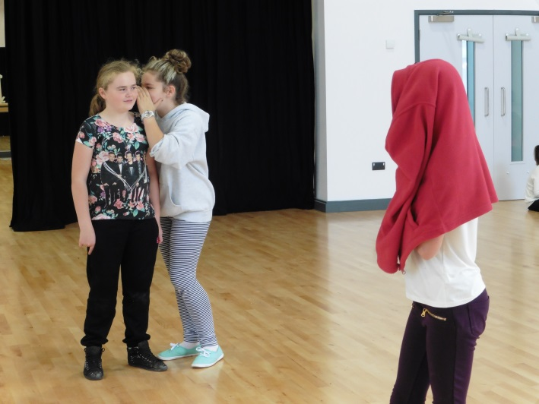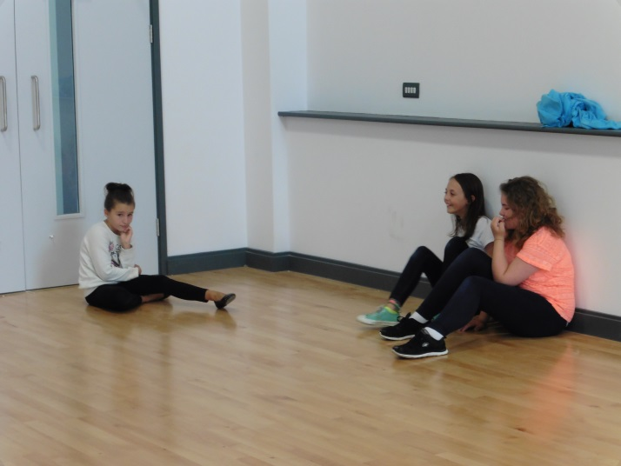

By day three, children were noticeably happier in each other’s company and in sessions. They were beginning to understand what was expected of them and were making a real effort to commit to games and do well. We started our morning by developing a completely new skill – Capoeira, a Brazilian fighting dance. Students were taught about the history and purpose of this fighting dance (dating back to the times of slavery) and were instructed in some basic introductory moves – both attacking and defending. The challenge was not to hurt their partner, but to work with them, creating a movement sequence that was focused, controlled and collaborative. This was a new skill for all participants and was incredibly beneficial – I was amazed at how focused and determined participants were, and their eagerness to learn, improve and master these skills was truly inspirational. I particularly enjoyed seeing how supportive students were of one another, and saw a noticeable difference in the focus and concentration levels of the group after this activity.

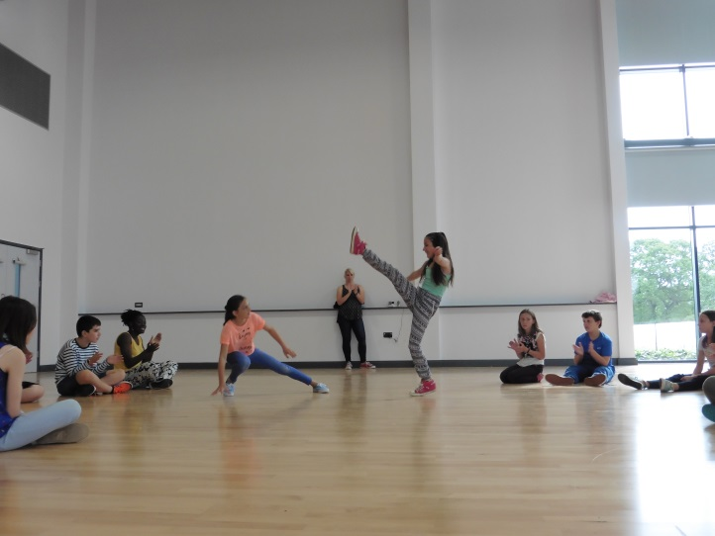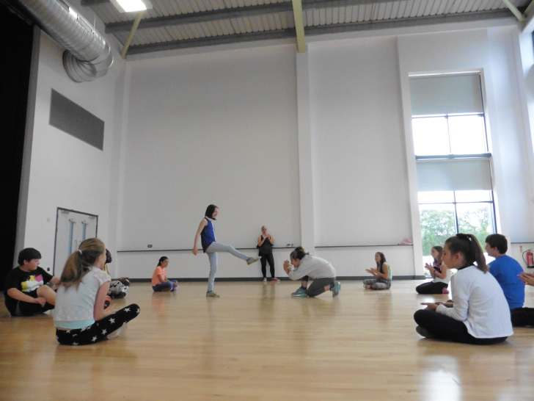

After our morning of Capoeira, we came back together as a group and continued discussing the move to secondary school – until this point, we had focused a lot on the problems that could arise with changing schools, but today we began to think about all of the positive things that could come from changing schools. The participants came up with some fantastic and mature responses to this question, suggesting things like more independence and responsibility, exciting new subjects, better facilities and being able to have a different relationship with their teachers (as classes were smaller, children were hoping that they would be able to get more attention and support with their learning). This led us on to the idea of goals and aspirations, discussing what a goal is and how someone might achieve different goals. I was delighted when some young people volunteered to share their personal goals, and we were able to discuss as a group what positive steps could be taken to achieve these goals.

To explore this theme further, we split the group into small teams, and asked each group to choose a goal (this could be the goal of a group member, or not) Each group came up with three steps that could be taken to achieve these goals, and used their tableaux knowledge from Monday to create three frozen pictures illustrating how these goals could be attained. The tableaux were extremely clear and controlled, and demonstrated the progress that had been made since Monday. I was also impressed with the creative ideas and steps that each group had thought of to achieve their goals.

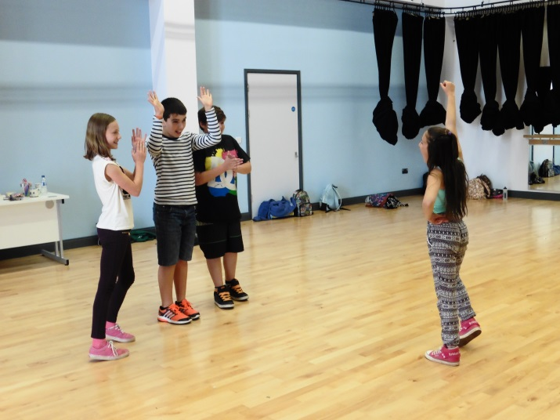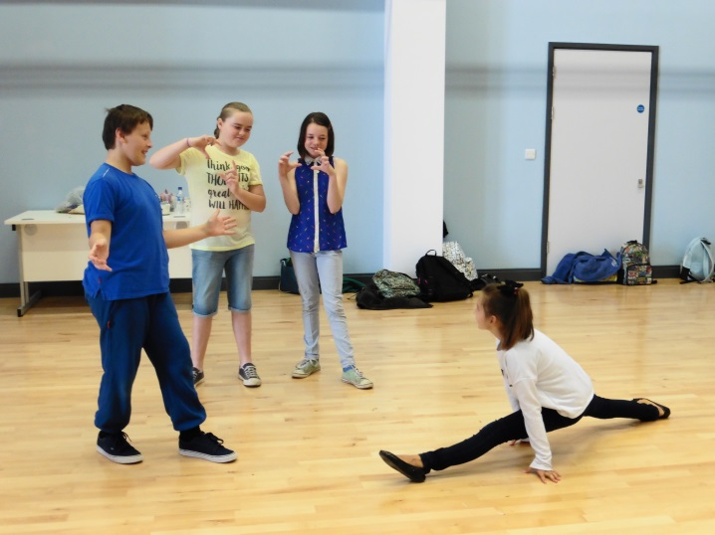

We spent the remainder of the session continuing to think about the positive things that come with moving to secondary school, and devising short adverts to sell the school. We thought about the different things that make a successful advert (it should be catchy and memorable) and each group worked turned our list of secondary school positives into an advert, encouraging others to come to Cranbrook Educational Campus. These were a huge success, with individuals really coming out of their shells – we discussed how a lot of adverts contain characters who are larger than life, and I was amazed at how many of our participants threw themselves into creating something that was genuinely funny (regardless of how self-conscious they might have been) this was a moment that showed me how much progress our participants were making – while on Monday, many seemed worried about looking silly, by Wednesday they were all comfortable enough to put themselves out there and to laugh with one another, not at one another.

For our afternoon session, we decided to take a break from drama, and took the children for a tour of their new school. While many rooms were still locked or unfurnished, the children were genuinely excited to see their new school, and their pleasure at seeing lockers, science labs and the D&T suite (to name a few) was unfeigned, and a real pleasure to watch. It was great to see the children so excited about starting their new school, and reinforced the idea that they were feeling confident and excited about this big change.

We also began working on costumes, which involved designing T-Shirts to be worn during the sharing. We were all amazed by how much effort went into this process – the children really embraced the opportunity to express themselves and create something unique to them, and all of the T-Shirts looked fantastic! Everyone managed to create something that they were really proud of, with an element of uniform included (a green tie, which will be part of their uniform next year) combined with their own personal style and design.

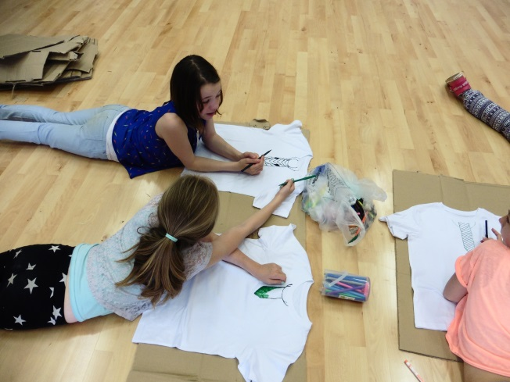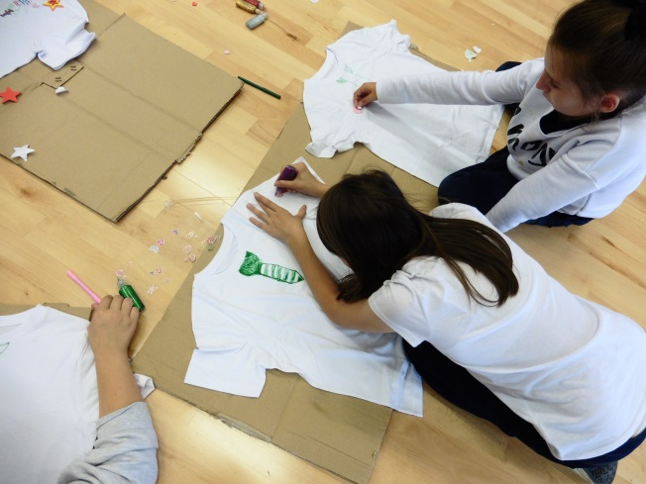

Up until this point, our aim had been to try out lots of different ideas and techniques, however our aim for Thursday was to start considering which elements of our work we wanted to include in our sharing. To see what the participants remembered, we started the day with a game of Write and Run – a team game where the children had to work as a team to write down the things that we had done over the week, and the skills that they had developed since day one. The idea of this game was to refresh the young people’s memories on everything that we had done this week, and we were delighted to see not only the different things that they remembered, but the skills that they felt that they had developed in our time together.

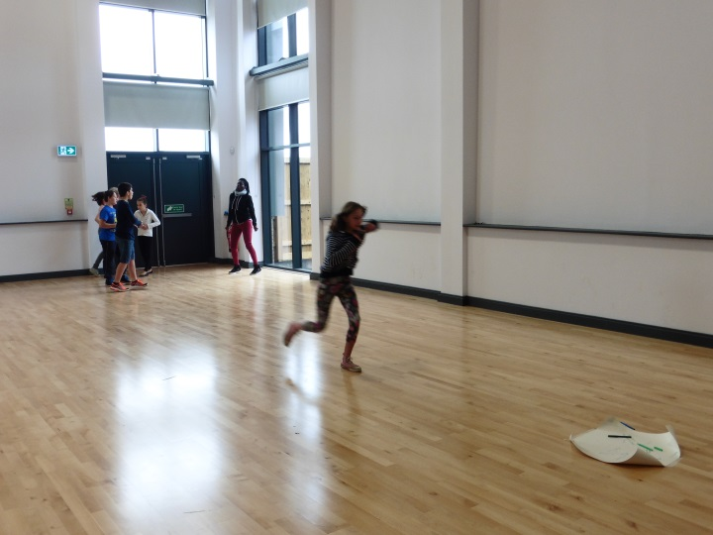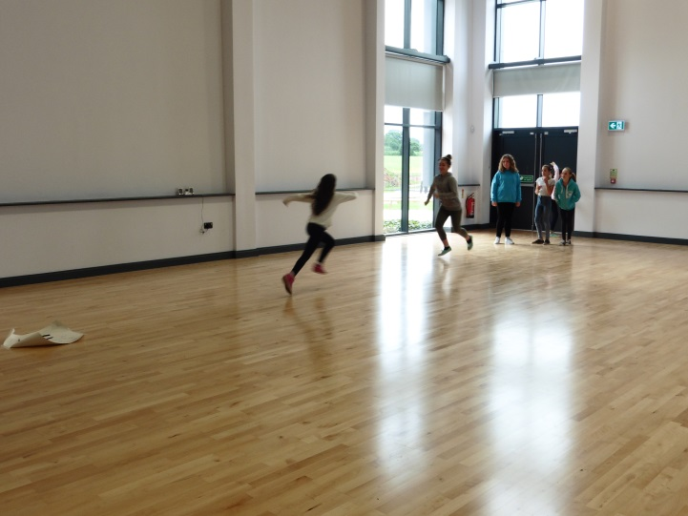

After reminding ourselves of the different things that we had done this week, we discussed which elements of our work we wanted to include in our sharing. The directorial team felt that it was important for the students to have a say in this, as it would give them a sense of ownership, independence, and responsibility for the material that was put together. As so many of our students wished to take on extra responsibility, we decided to let different young people host different sections of the sharing (usually this would be done by the directorial team) this was a real surprise, but we were delighted at the confidence that participants were exhibiting, and their determination to show off the group to the best of their ability.

Having spent the rest of the morning rehearsing and polishing for our sharing, we spent the afternoon in a new part of the school – the brand new playing field. This was not only a refreshing change of scenery, but very exciting for a lot of the children, particularly those hoping to get involved in sports teams. It was great to watch them explore the new space, and find something else that they were excited about in their new school. We arranged a group rounders game, and were delighted with the sportsmanship, teamwork and problem-solving that we saw within the group. Many participants thrived under friendly competition, and several pushed themselves forward in ways that we had not seen all week.

Before we began our session on the final day, we asked the children to complete another Bulls Eye chart, asking the same two questions from the beginning of the week. Most children seemed to have grown in confidence about moving to Cranbrook Educational Campus, and we were amazed at the number of children who now claimed that they knew everyone in the room fairly well or very well, and were absolutely delighted by this result after just one week. A huge part of this week was to allow the students to get to know one another and feel comfortable among their peers before starting at their new school, and we were delighted to see that this seemed to be the case on our final day together.

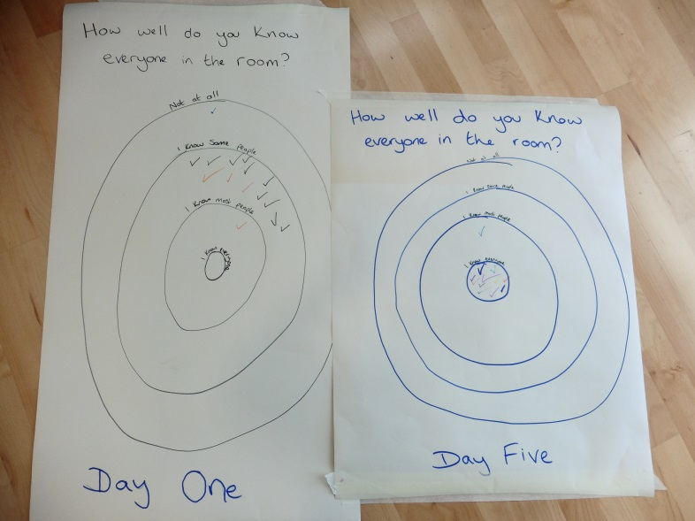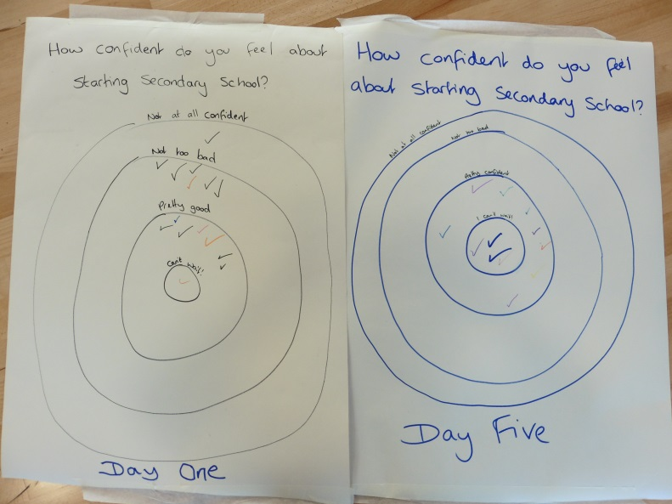

Our final day was completing the T-Shirts and polishing the individual components of our sharing, before putting it all together (with links from our young hosts) The children were all very excited to show their parents what they had achieved over the week, and seemed really proud of their work.

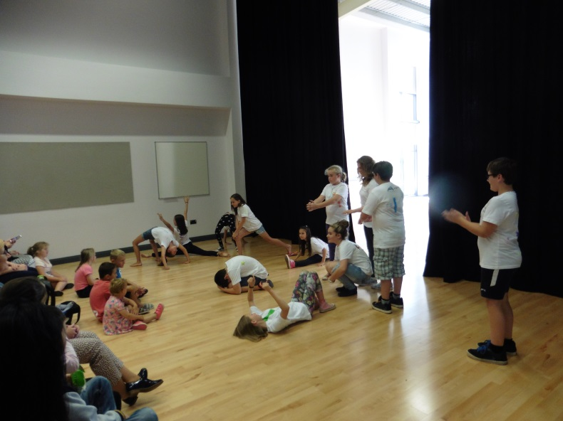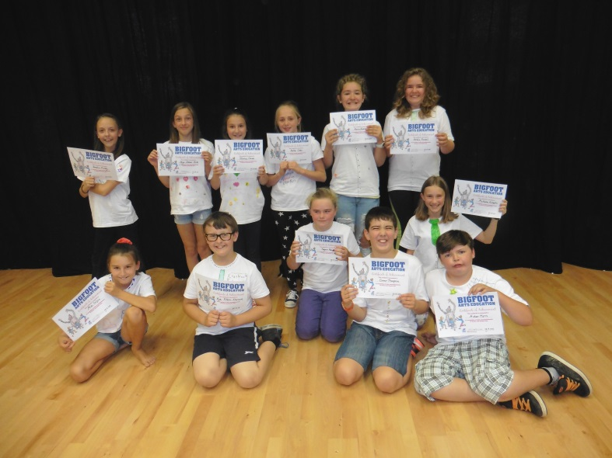

We ended with an awards ceremony to thank the parents and directorial team, and presented certificates to all participants. Parents were then invited to view a gallery of all the written work that we had done that week.
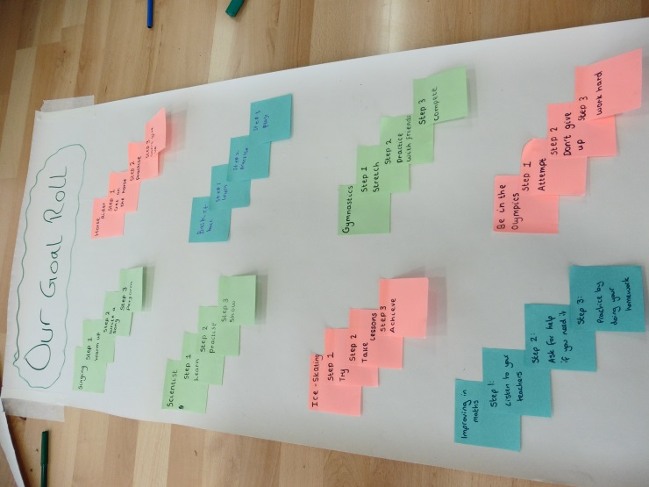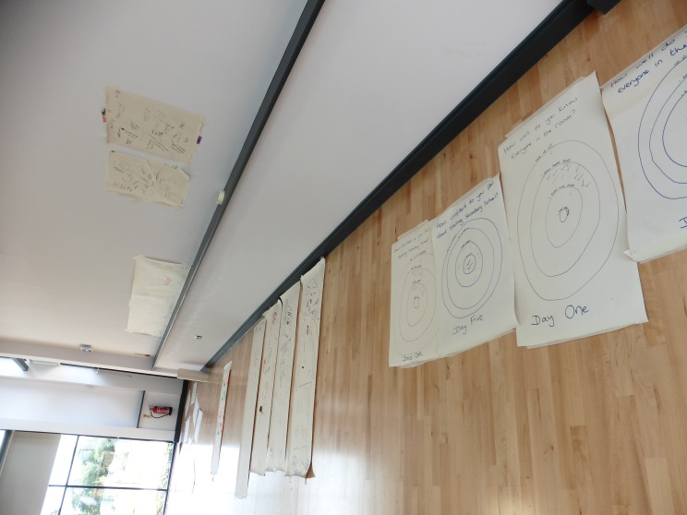

Increasing independence

A large part of this week was about entrusting our participants with more responsibility, instilling a sense of independence in them which we hoped would serve them well in secondary school. We wanted to encourage them to take responsibility for their own learning, so we gave each student a log book for them to write down their achievements and memories from our week together. These were private books that no one else read, but were used at the end of every day to reflect on our day’s work. They made notes on their achievements, the things that they enjoyed, and skills they wanted to develop, as well as personalising their books.

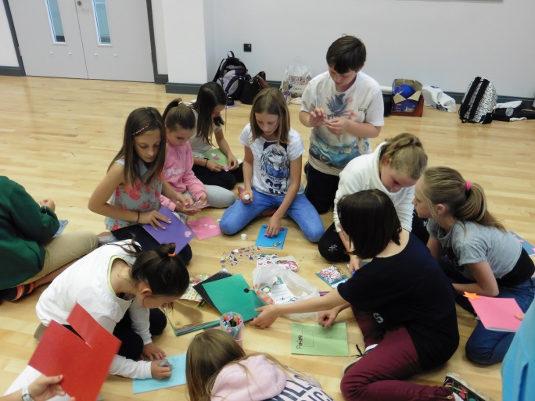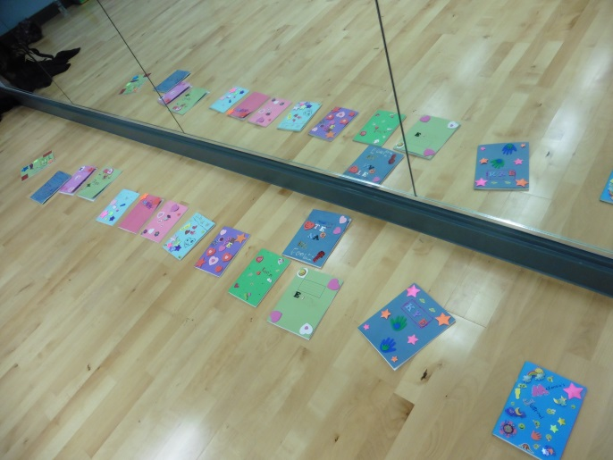

While these were private books, we did invite the children to share some of their thoughts on the final day. We taped several pieces of paper to the floor, each with a different skill written on it (such as listening, teamwork, concentration, independence etc) and invited each child to write down an example of how they felt they had used each skill during the week. We made it clear that this was not a test – rather, an opportunity for them to reflect on the work that they had done and what they had achieved in our week together. Again, this was aimed at encouraging independence through personal reflection and evaluation, and while we did know who wrote which comment, it was amazing to see our participants recognise positive change and development within themselves.

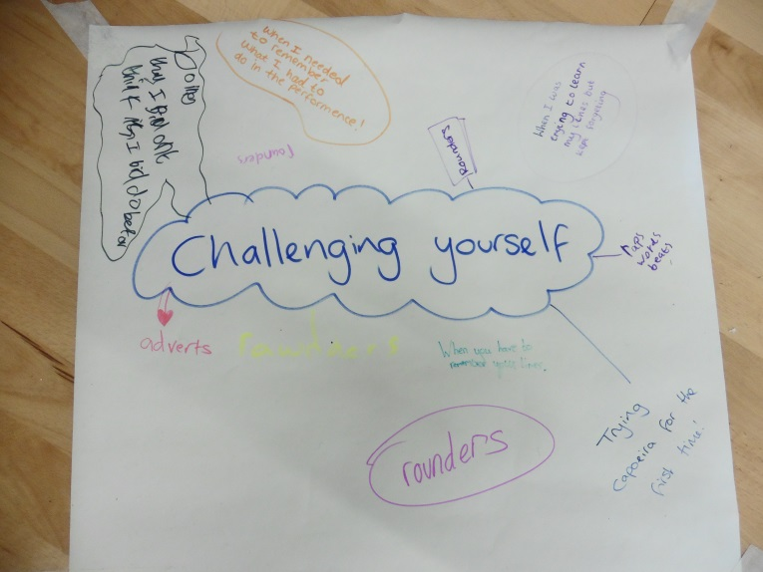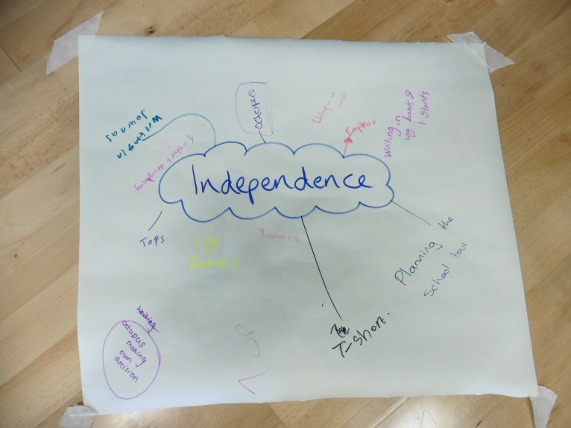

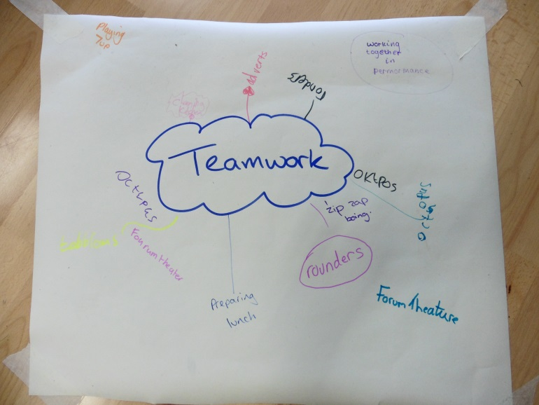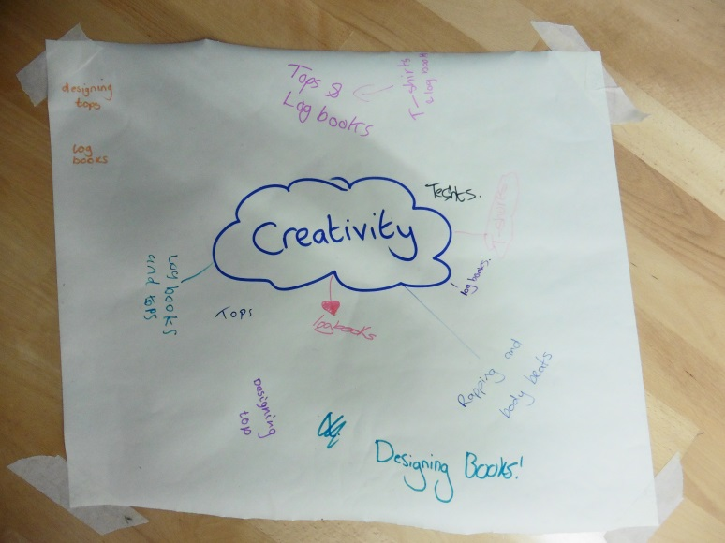

We also wanted to encourage our participants to develop a sense of personal independence, in being able to take care of themselves. While catering was provided, we felt that it was a positive step to allow our students to make their own decisions about lunch, and to take responsibility for making and providing it. We arranged one of the food tech rooms as a cafeteria, and gave the students all the instructions and information that they needed to prepare their own lunches on the first day. This was such a huge success that for the remainder of the week, we invited different teams of children to host their peers. This involved setting everything up, making sure the right equipment was used, and tidying the kitchen afterwards. While many had never made their own lunch before, all responded very positively to this increased responsibility and were particularly proud to host their friends. They all seemed to enjoy this new independence, and by the end of the week were providing their own healthy, balanced lunches with very little involvement from the adults present.

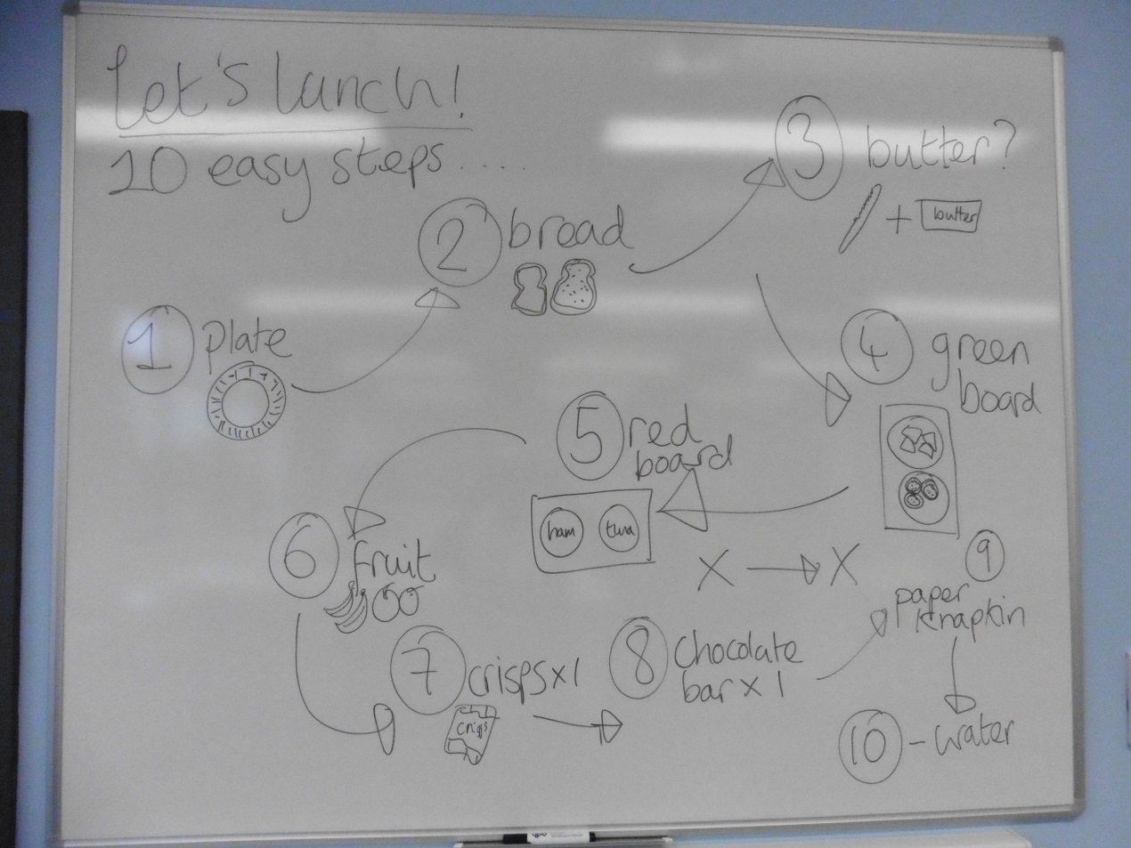

Literacy and Numeracy

While Bigfoot is an arts education company, our facilitators are much more than just performers. We believe that any branch of the curriculum can be enhanced through creativity, and understand the importance of developing literacy and numeracy in a child’s education. We made it our mission to include both in our summer school this week, with some extremely positive results.

Each day had a spoken and written element to it, which the pupils responded to very positively. We had a variety of discussions throughout the week about our work, about secondary school, and about the schools that they had left behind, and all were able to explain their points of view using increasingly detailed vocabulary. Their personal log books were an opportunity for personal reflection, and activities such as Write and Run, labelling our body outlines, and creating our Goal Roll involved not only writing, but describing, evaluating, and even creating simple sets of instructions. There was a wide range of literacy levels within the group, but all were able to contribute to group writing activities, and do so with carefully considered and thoughtful responses.

Numeracy was also tackled throughout the week. Each child was given a number on day one, and constantly had to remember this as they were often grouped by numbers. Once they had mastered the idea, we began making things more tricky by encouraging them to work out numbers themselves (for example: stand up if you are an odd number, an even number, a prime number, a multiple of three etc) which they viewed as an exciting extra challenge. We also played a variety of number games, some of which involved passing a beat from one number to another, and others of which involved mental arithmetic (we would shout out a sum, and the children had to work out if their number was the answer) As the week progressed, children became much more confident in playing number games and using numeracy within our work.

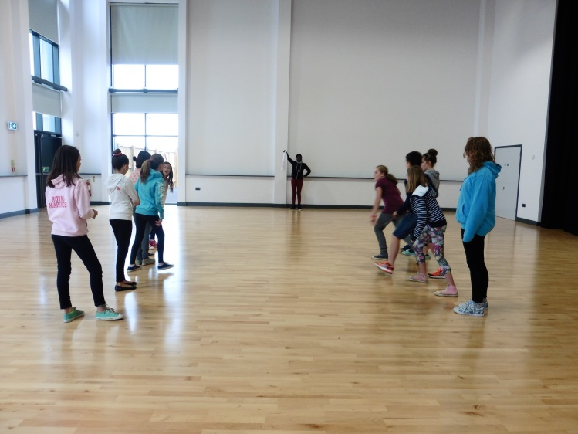

While it was always made to feel fun and exciting, I believe that the children have had an opportunity to develop both literacy and numeracy this week. By exploring both in a fun and secure environment, it removes the pressure (particularly for those who may be self-conscious about these subjects) and allows each child to get involved and have a go. The result has been an increased confidence in speaking, writing and number work, which I hope will translate to their secondary school work.

Individual Progress – Case Studies

Chris arrived at Cranbrook Summer School on Monday morning appearing to be restless. He participated well in all the energetic games, but displayed minor disruptive behaviour during activities requiring more focus. He shared with some of the groups that he had been bullied in primary school for five years. On the second day, Chris’ focus was stronger as he remained on task and more engaged better in all the various activities. He made an impressive contribution to group discussions leading to developing scene work in small groups and confidently shared ideas with his peers. Over the week, Chris made progress in team work and showing initiative in group interactions as well as volunteering to set up lunch with, and for his peers. Chris took ownership of his work with great confidence which he proudly shared in front of an audience.
Teresa arrived on the Monday completely reserved and withdrawn. She took part in the day’s activities, though with little enthusiasm and choosing to spend lunchtime away from the majority of her peers. On Tuesday she showed more interest in group activities and her confidence soared during improvisation exercises proven by her willingness to be in every scene. In spite of falling ill during the week, Teresa showed her commitment to the project by attending. She grew very keen to learn new skills and include her learning to the sharing of work. This increased her confidence and she demonstrated excellent teamwork during a game of rounders.
Fatima arrived on Monday with a group of friends, but despite knowing others in the room she seemed very quiet and shy. She actively sought out her friends for pair work and during breaks, and seemed nervous about mixing with others. While she participated in every activity, she seemed self-conscious and did not want to look silly. However, by day two I noticed her making a real effort to push herself to try new things – she seemed to have made the decision that she wanted to have a go, and make the most of this opportunity. She worked well with new people, being sensible and a natural leader (without being overbearing) and really pushed herself to try new things. I could see how nervous she was about forum theatre, but the fact that she volunteered of her own accord to step in was a huge achievement, and she seemed understandably proud of herself. Her work went from strength to strength as the week progressed, and by the end of the week she had become a well-liked and dependable member of the group.
Ricardo arrived knowing no-one on the first day, having just moved to the area. He seemed nervous but willing to get involved, however the directorial team had concerns that he might be intimidated by a group that had so few boys. Our worry however, was completely unfounded – from the first morning, he was extremely happy to throw himself into any activity with a confidence that was very pleasing to see. His willingness to work with others and make friends was inspiring for others, and his natural cheer and friendly nature brightened up the working environment. As the week progressed, he was able to develop his performance skills and use his natural determination and charisma to push himself. He performed with pride in our final sharing, and no one would have guessed that he had arrived knowing no one on the first day.

Conclusion
Our week ended with a sharing for family and friends (the sheer amount of audience present was a huge testament to how proud our students were and how much they wanted people to see their work!) Having discussed content the day before, we were delighted with how much the children wanted to share with their parents, and were able to demonstrate a huge variety of skills and performance techniques – all presented and hosted by students. The children demonstrated how goals can be set and achieved and adverts selling their new school, as well as actively problem-solving through forum theatre and raps. The children were also very keen to show off their new Capoeira skills, and ended the sharing with a catwalk to parade their T-Shirts!
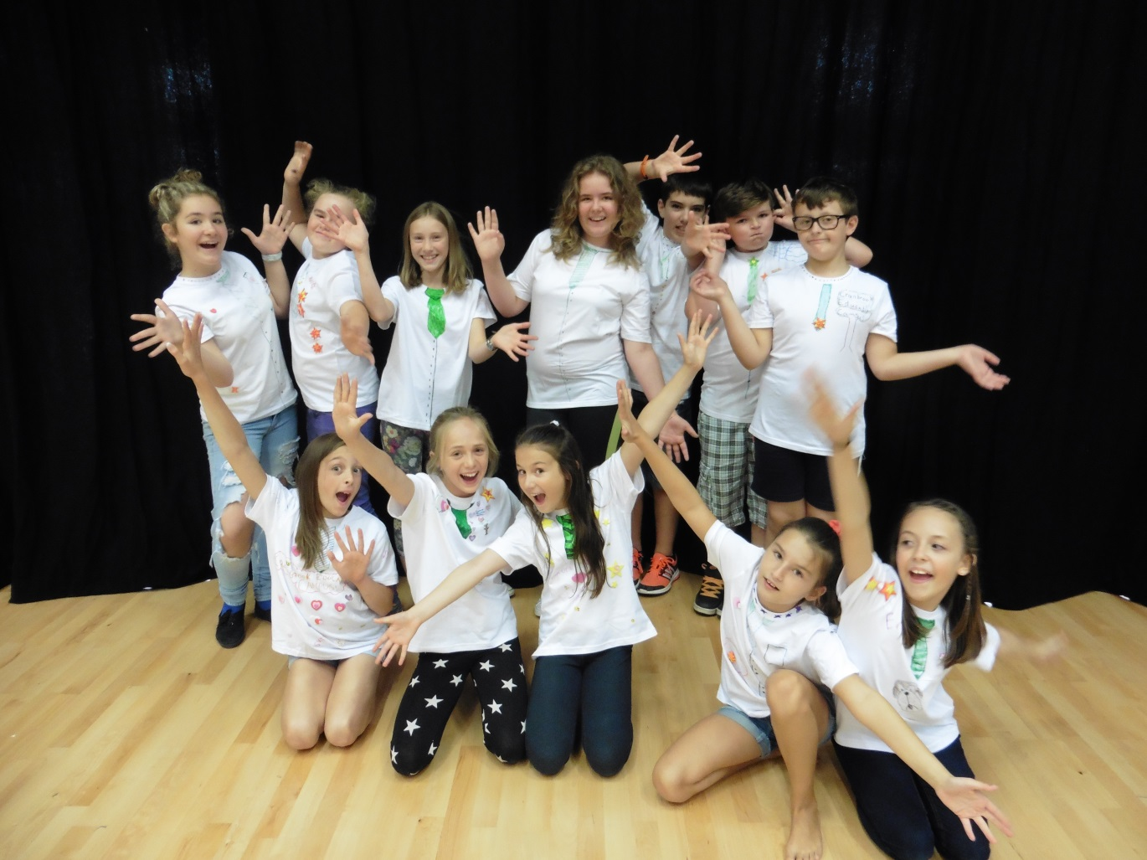
Following on from the performance, we allowed time for an awards ceremony, in which we not only thanked parents and the directorial team for their support, but presented certificates to the young people who had performed. We were able to individually acknowledge the children and the contribution that had been made to summer school, which I think was appreciated by children and parents alike (one mother commented that it was clear how much time we had taken to get to know the children, which was lovely to hear) We then gave the children time to sign one another’s log books while their parents explored our gallery – a final farewell after a wonderful week.
I believe the Bigfoot Summer School at Cranbrook Educational Campus was a huge success, and hugely valued by the participants. A new school is an unusual situation for any child, but one that is still being built presents difficulties of an entirely different nature. This week was a rare and incredible opportunity for the future year sevens of the school to find their feet and make their mark on what was, essentially, a blank canvas. They were able to not only develop as performers, but to make friends, explore their new environment, ease their worries about the transition, and embrace the positives about starting in a new school. By creating a safe and welcoming environment for work, the directorial team were able to support these developments and instrument these positive changes, and I know we were all amazed by the transformation in our participants by the end of the week. As a member of the directorial team, I can honestly say how proud I am to have worked with such a wonderful group of young people, and I am confident that this week has equipped them with some valuable tools for the years ahead.
Participant and Audience Testimonies

“My daughter is feeling so much happier about starting school next week!” – Parent

“I can work with other people better” – Student

“My son has really benefitted from this week – he has come out of his shell and stopped being so shy” – Parent

“I understand more about forum theatre and have developed new skills” – Student

“I think your work is amazing, so thank you for making my son feel so much better about starting Cranbrook” – Parent

“I understand how to overcome my fear about high school” – Student

“Her confidence in starting high school next week has grown” – Parent

“I can be brave” – Student

“Keep doing what you’re doing, you have and are doing a great job. She has had the best week and has looked forward to coming every day” – Parent

“I understand more about problems in secondary school, and have improved my confidence” – Student

“My daughter has met some of the children who she will be in class with, which is very beneficial” – Parent

“I can now perform in front of an audience” – Student

“My son has come away with confidence, commitment, happiness and friendship” – Parent

“I can speak in front and work with everyone” – Student

“I believe it has met every expectation and lots more – thank you very much!” - Parent

“I can do Brazilian Dance (Capoeira)” – Student

“She had so much fun throughout the week! No wasted time in front of the TV or laptop. She loved doing drama and meeting new people, it was great for her!” – Parent

“I can make friends, and understand more about teamwork” – Student

“No improvements. She loved everything and everyone – especially the staff, who know how to make children happy!” – Parent

“I can feel more confident” – Student

“No way of improving the week – she really enjoyed it and is a lot more confident about starting school!” – Parent

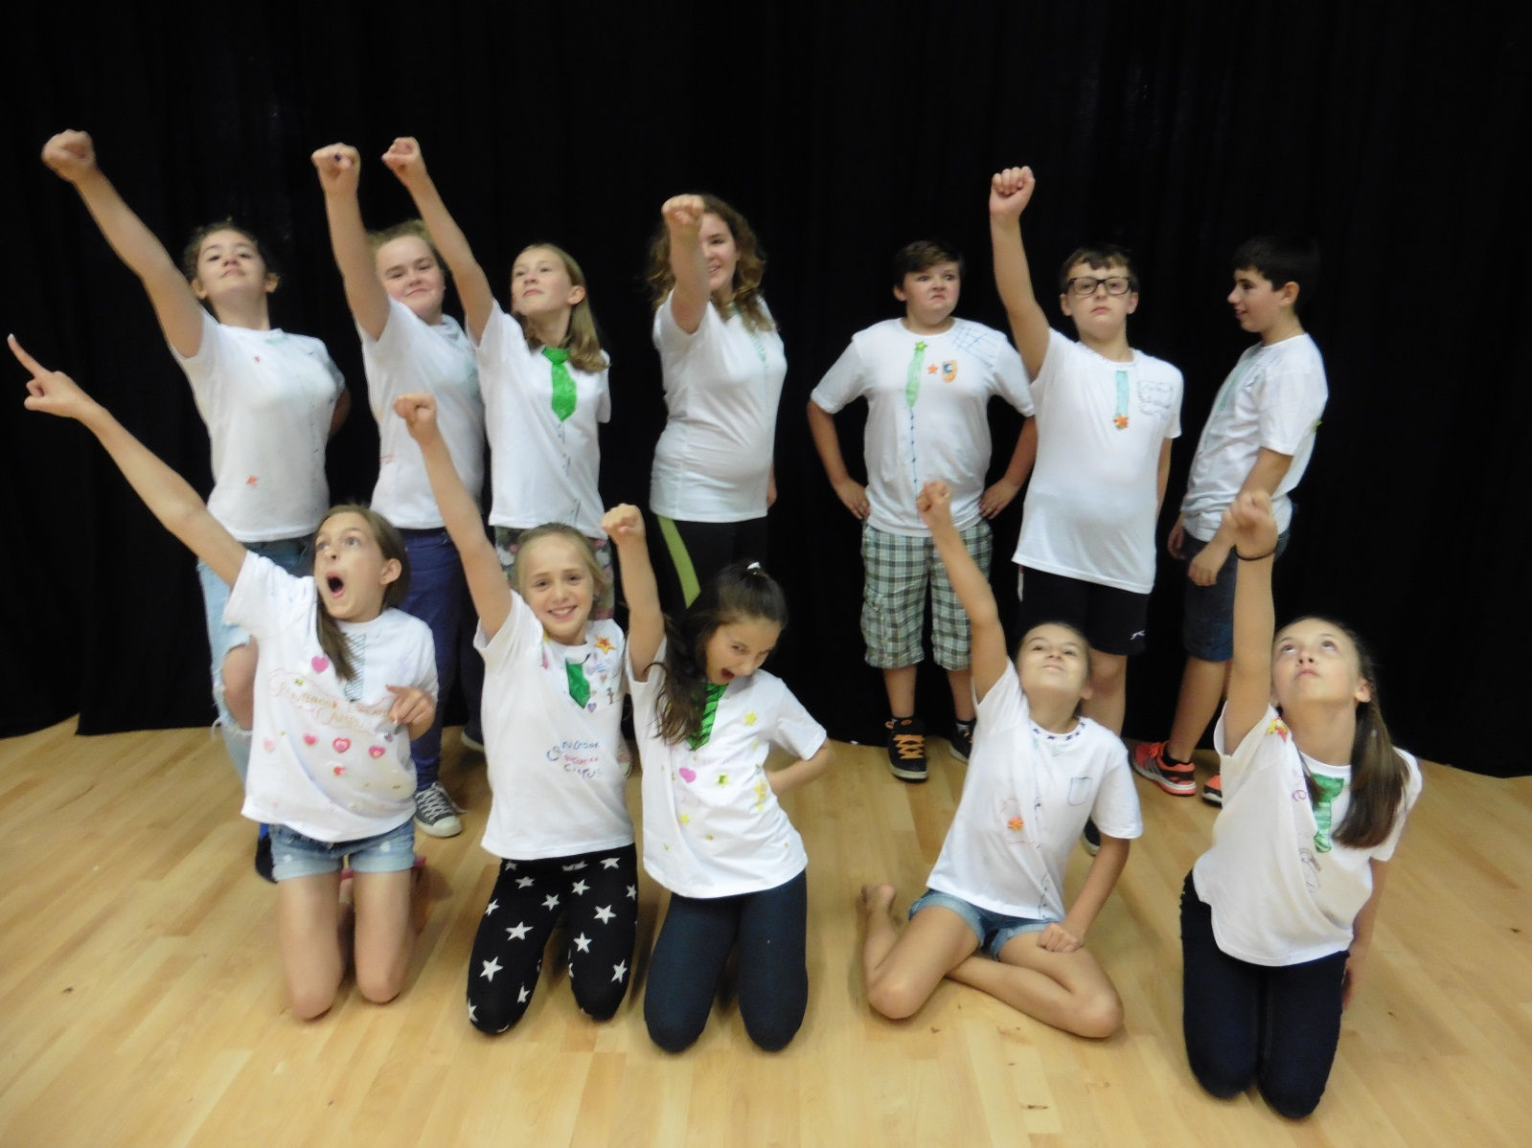
Cranbrook Educational Campus………………
WE’RE READY FOR YOU!!!

Statistics

- In their initial questionnaire, 93.3% of students said that they felt either ‘Quite Confident’ or ‘Very Confident’ about starting secondary school. In their final evaluation, this changed to 100% of students (with 82% claiming to feel ‘Very Confident’)
- When asked in their initial questionnaire whether they thought they would feel any different at the end of the week, 60% said ‘Maybe’, with 27% saying ‘Yes’ and 13% saying ‘No’.
- When asked at the end of the week whether the course had helped them to feel better about starting secondary school, 83% of students said ‘Yes’, with 17% saying ‘Maybe’.
- When asked in their initial questionnaire, ‘How many people do you know who are going to your new school with you?’ 40% claimed to know a lot, 47% claimed to know a few, and 13% were unsure. In our final evaluation, 82% claimed to have made new friends during the week.
- This was also supported by our Bulls Eye tick boxes, which indicated how well people felt they knew others on days one and five:
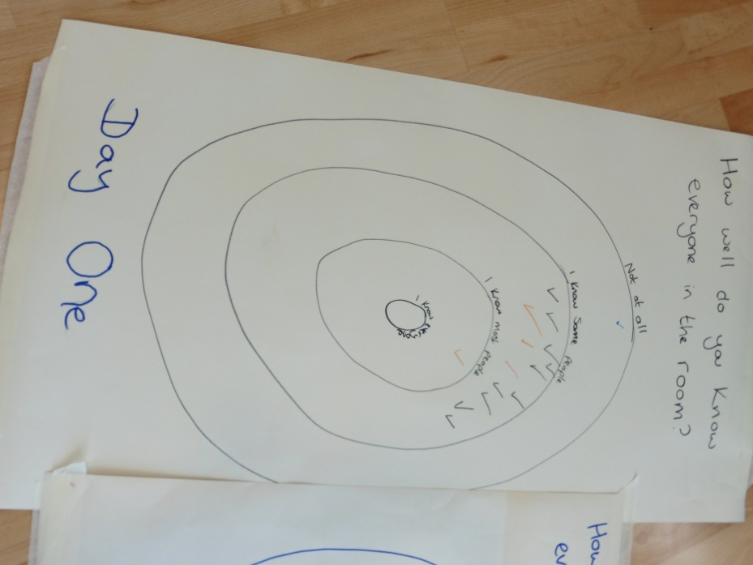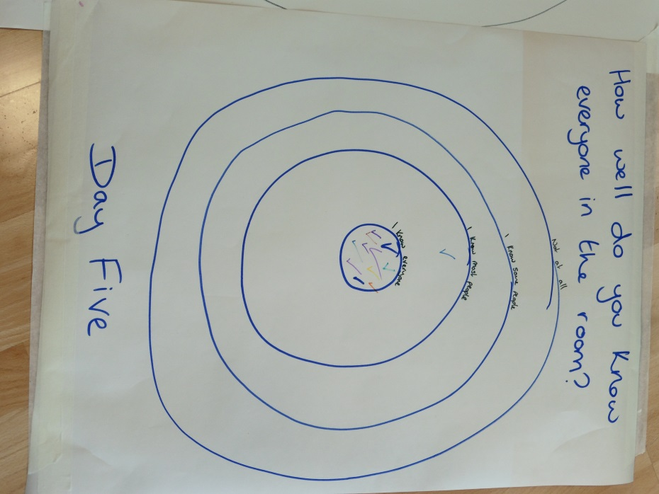

- The initial questionnaire asked students to indicate what they would like to get out of the course (they could choose as many or few as they liked):
    - New friends – 27%
    - Confidence – 7%
    - Getting used to the school – 80%
    - Learning new skills – 0%
    - Having fun – 53%
- It also asked students to indicate what they thought they would learn this week (again, they could choose as many or as few as they liked):
    - How to work with others – 53%
    - Fun activities to play at break times – 13%
    - How to be confident – 53%
    - Speaking and listening skills – 7%
    - Performance skills such as acting, devising and role play – 13%
- We compared these figures to our final evaluations, where the students indicated what they thought they had taken from the course:
    - New friends – 75%
    - Confidence – 42%
    - Getting used to the school – 33%
    - Learning new skills – 50%
    - Having fun – 58%

These figures represent the diversity of Bigfoot Summer School – our participants feel that they have walked away with a huge range of skills and positive experiences from the week, not all of which are performance-oriented. These figures, combined with the individual comments above, are a testimony to a truly successful week, and – we hope – a positive start for the pupils of Cranbrook Educational Campus.

