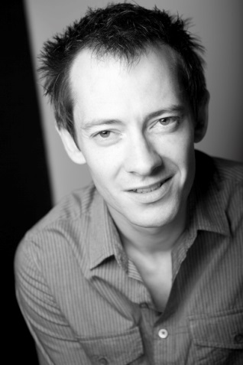
Ben Neale
Ben Neale
Bigfoot CV

Bigfoot CV

DBS Number: 001432709314
Issued: 24th January 2014
Update Service: NO
Bigfoot Arts Education guarantees that all appropriate checks in respect of safeguarding children have been carried out.

A bit about me…

I am an actor and workshop facilitator with 13 years’ experience of theatre, workshop leading, improvisation, film, interactive performance, installation and Live Art. I have worked with Bigfoot for the past three years as a facilitator and more recently also as a Bigfoot Advocate & love it! I have worked with children of all ages, spanning a wide range of ability and behaviour. As well as theatre, I teach mask, storytelling, devising, clowning, physical theatre, improvisation and listening & social skills.

My art specialisms…

- Mantle of the Expert
- Dickens
- Codes for the Roads
- Think Simple Act Big (Refugee Week)
- Rights Respecting Schools
- Big Steps
- History
- Clowning
- Comedy
- Juggling
- Mask
- Object Manipulation
- Physical Theatre
- Puppetry
- Shakespeare
- Stage Combat
- Storytelling

Me as a professional artist…

- I have performed opposite Billie Piper & Kris Marshall in London’s West End
- At Art Festivals from Melbourne to Bogota…
- Internationally with the superb Forced Entertainment
- Appeared on the BBC, ITV, Channel 4 & the History Channel
- And to more children than any statistic could give impact to!

Me as an experienced facilitator…

- Bigfoot Facilitator, Bigfoot Advocate and Bigfoot Summer School Director: ages 4-12.
- Holiday Activities Workshop Facilitator for Nimble Arts & Chichester Festival Theatre.
- Artis Specialist: on-going PPA cover, project & cover workshops to 3-11 year olds.
- Ladder to the Moon Creative Practitioner: co-designs and leads workshops in Connected Teams, Creativity, Activity and Wellbeing with staff in health and care organisations.
- Co-designed and led Creative Learning workshops in business settings.
- Fuse Theatre Productions Education Officer. Designed and led workshops for 15-25 year olds in theatres, secondary schools, community centres and residential housing for socially excluded young people.

My Education & Training…

Victoria College | 1985 – 1997 | GSCE’s: 7A* (English Language, English Literature, Maths, French, History, Biology, Physics), 2A (German, Chemistry), 1B (Art)
 |  | AS Statistics (B)
 |  | A-Levels: Maths (A), English (A), French (B)
University of Warwick | 1997-2000 | English and Theatre Studies BA (Hons). Class two, division one.

