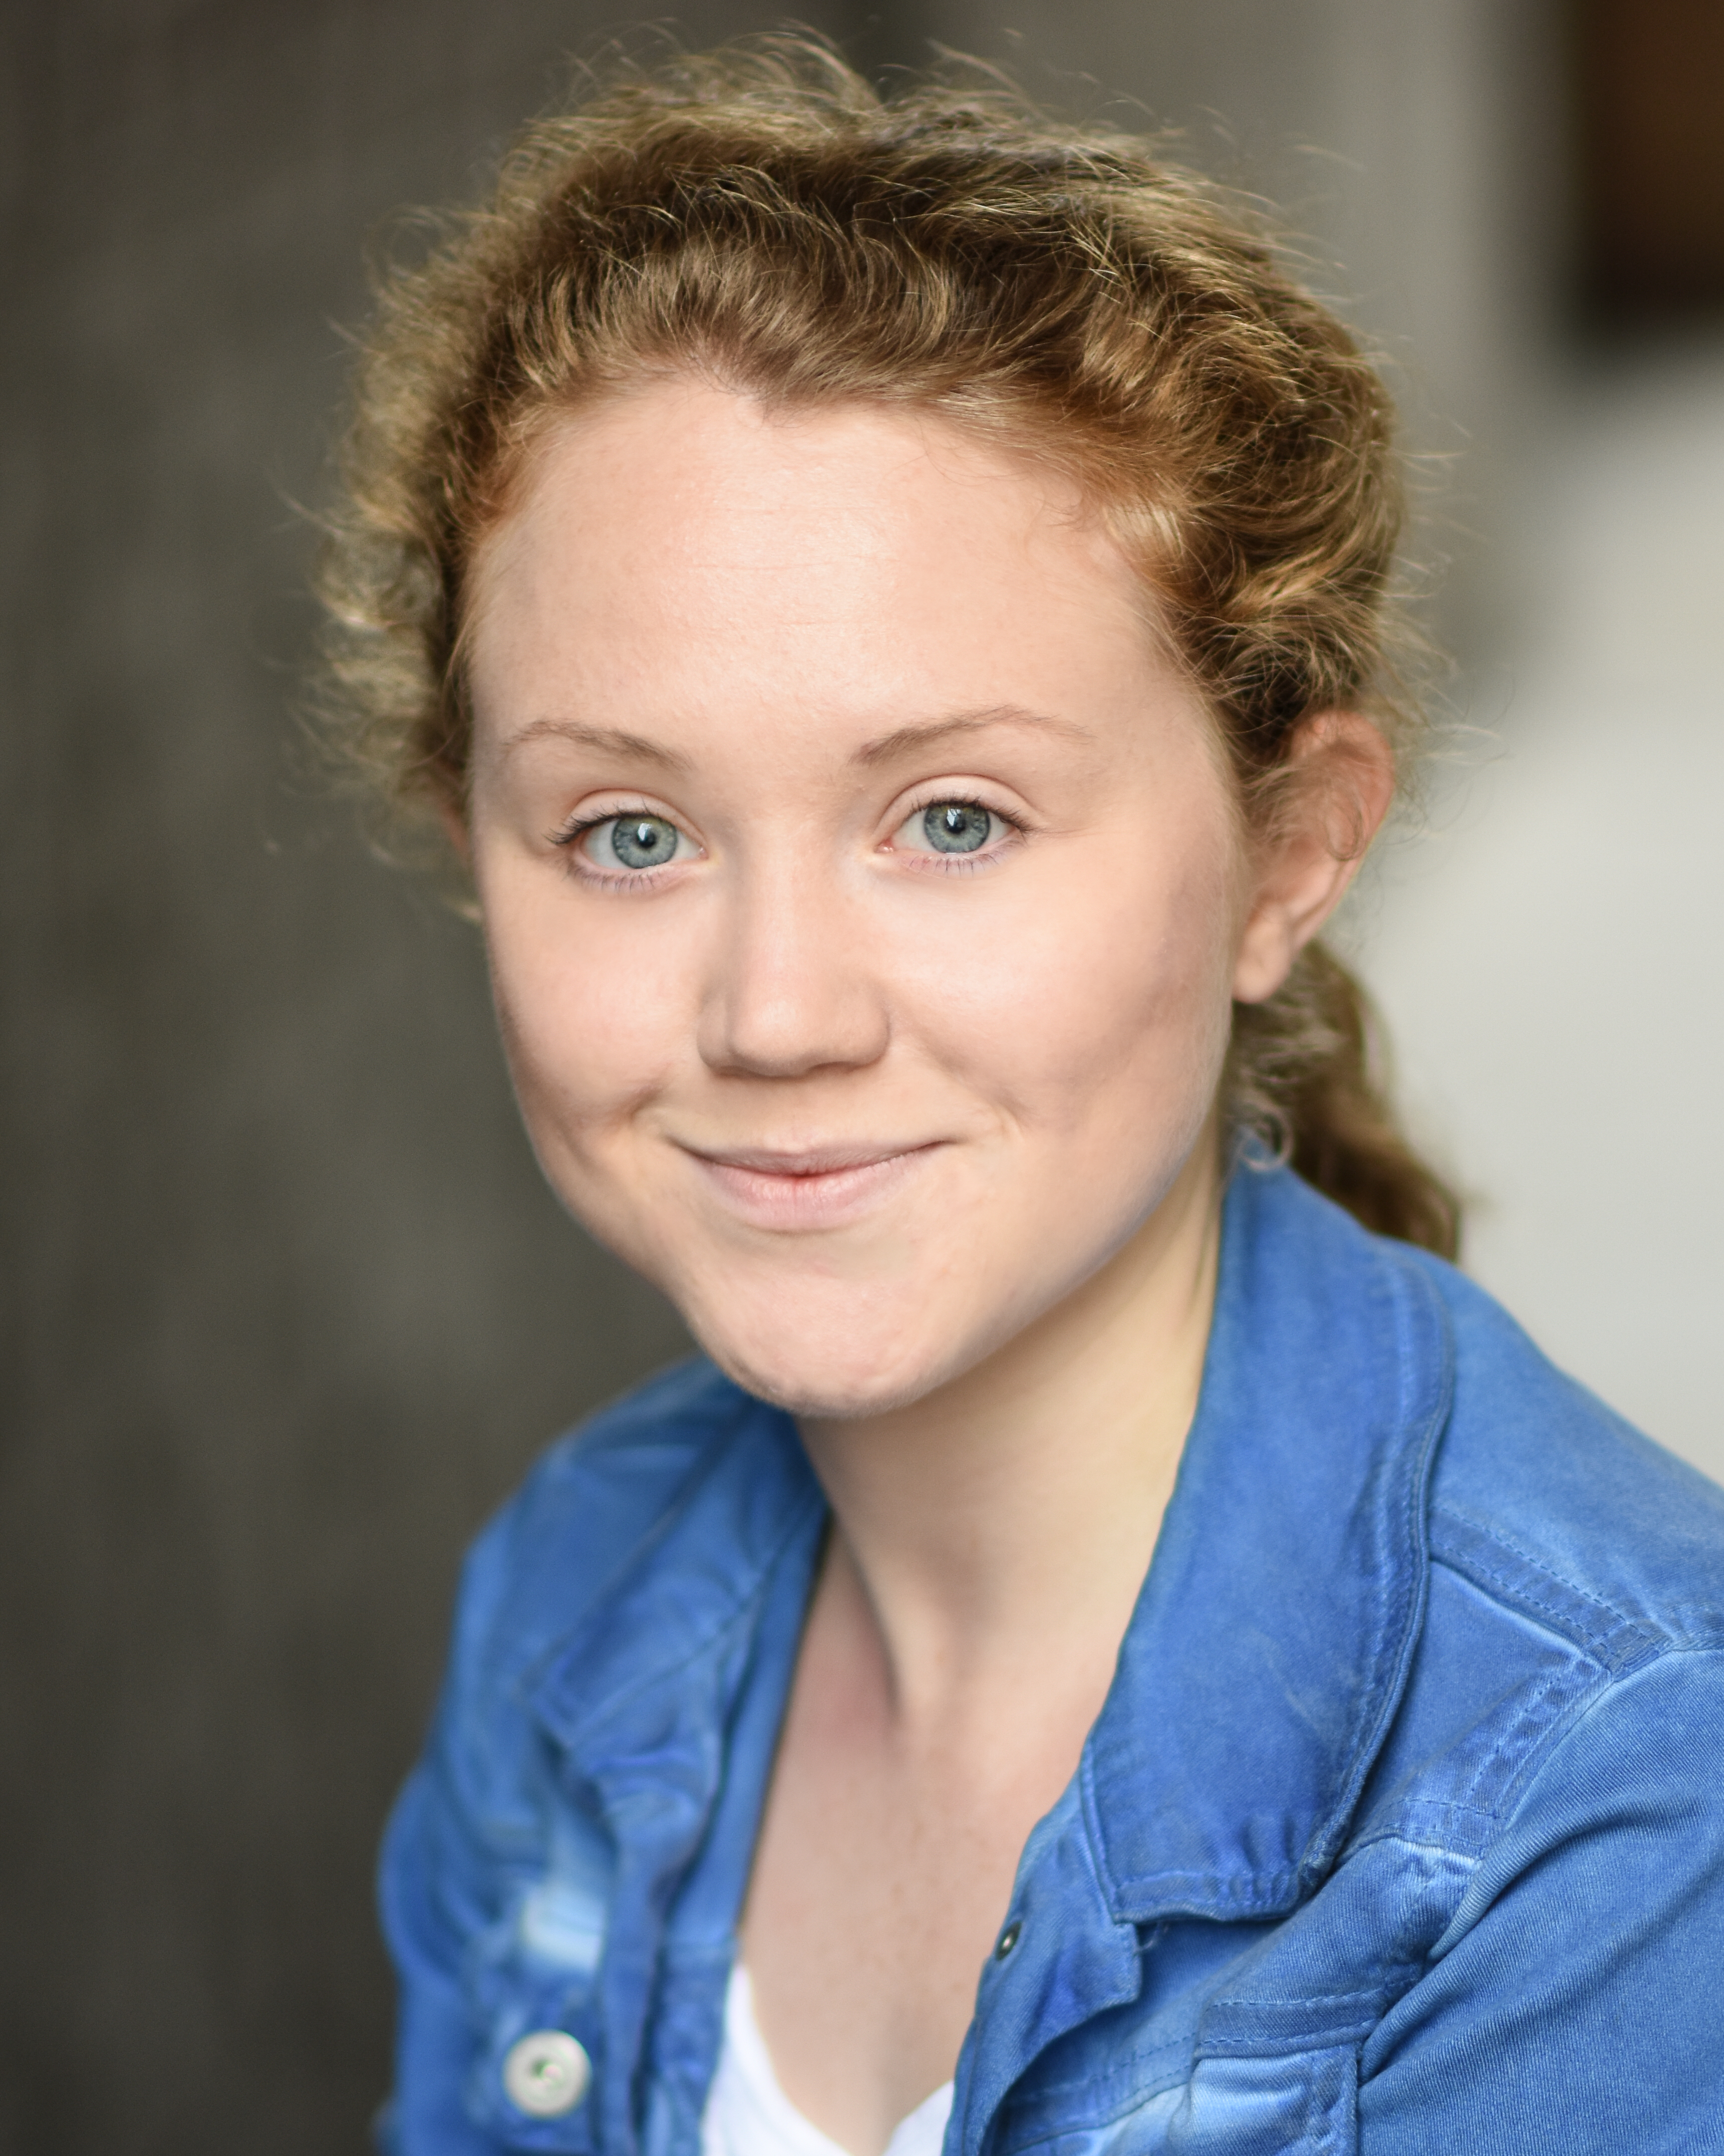
Rebecca Drake
Bigfoot CV

DBS Number: 001651062941
Issued:14 March 2019
Update Service: YES
Checked: 06/08/2021
Bigfoot Arts Education guarantees that all appropriate checks in respect of safeguarding children have been carried out.

A bit about me…
A professional actor with particular interest in voice work and playing multiple roles. I enjoy improvisation and storytelling! Since creating a curriculum aligned performing arts programme for 3-11 year olds in 2014 I have been passionate about extending learning through creativity and I think creatives like myself are the people to do it. I work with the Girls Brigade giving talks and mentoring sessions on confidence and self-worth. Alongside performing and public speaking I have a passion for writing and spoken word poetry.

My art specialisms…
- Storytelling
- Makaton songs and nursery rhymes
- Stage Combat
- Improvisation
- Spoken word poetry
- Shakespeare

Me as a professional artist…
- Performed at Theatre N16 as Amelia in award winning comedy 'Swing By Around 8'.
- Worked with multiple award winning film makers Sam Hogarth and Alex Arnold.

Me as an experienced facilitator…
- Green Lane Primary School Performing arts team - drama and voice coach.

My Education & Training…

Whitchurch high school, Cardiff | 2011 | GCSE English Lit/Lang/Maths/Science/Additional Science/Drama/History/German/Music/RE/Welsh
Whitchurch high school | 2013 | Alevel Drama, A/ History, B/Politics, B
The Court Theatre Training Company | 2014-2016 | BA Hons. Acting, 2:1

.

