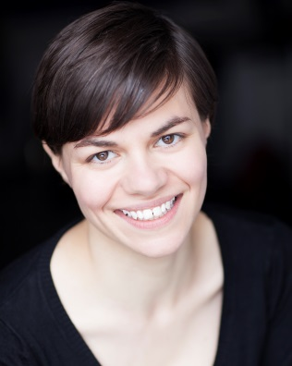
Ceri Smith
Bigfoot CV

Ceri Smith
Bigfoot CV

DBS No: 001473363141
Issued: 21st January 2015
Update Service: NO
Bigfoot Arts Education guarantees that all appropriate checks in respect of safeguarding children have been carried out.

A bit about me…

I am an enthusiastic and lively facilitator. I have worked as a Bigfoot facilitator for three years and have experience of teaching all ages from 3 to 18. I work regularly as a professional actor and believe in bringing these skills into the classroom to enable students’ learning and engagement. Prior to training as an actor I was a full time secondary drama teacher.

My art specialisms…

- Drama

Me as a professional artist…

- Professional actor and actor-musician
- A wide range of credits including national and international tours
- Regularly works on London fringe in contemporary and classical theatre
- Musical theatre experience
- Artistic Director/Head of Education at Speaking in Tongues Theatre Company, producing work in London and internationally, working with young people aged 16+

Me as an experienced facilitator…

- Creative Supply facilitator at a large number of schools
- Actor/PSHE facilitator at a large number of Primary/Secondary schools
- Actor/facilitator on Transition from Y6-7 at a large number of schools
- Summer School leader at Fulham Cross girls’, Acton High, Kingswood and Jo Richardson Community Secondaries
- After school club facilitator at Clapham Manor, Haimo and St Thomas Primaries
- Actor/facilitator on Curriculum Enrichment at Wilburton Primary
- Actor/facilitator of bespoke programmes on Knife Crime, Discrimination at Bexley Pupil Referral Unit and Haverstock school
- PPA facilitator at Lyon Park and William Davis Primaries
- Go Mantle facilitator at Stanhope Primary

My Education & Training…

Nottingham High School | 1997 | GCSE’s: 9 at A*/A
 | 1999 | A Levels (A/B): English Literature, History, French, General Studies
University of Bristol | 1999-2002 | 2:1 BA Drama and English Joint Honours
University of Leeds | 2002-2003 | PGCE: Drama
Drama Centre London | 2008-2009 | MA in Acting (Distinction)
Bigfoot Arts Education Professional Development Courses | 2010 to present | Two Day Induction  PPA & Supply  Working creatively with EYFS/KS1  Devised theatre  Advanced facilitation  Assessment  PSHE - various  Transition: Moving on Up and Big Steps  Play in a Day  Mantle of the Expert  Charlie the Time Traveller  Best Foot Forward/Change for Life  Super Healthy Me
Full Clean Driving Licence | 2002

